encapsulation

* What is Encapsulation?
  + define classes focusing on what is important for a purpose
  + hide data and implementation details inside a class
  + make all methods private
  + use of words to define classes
* What is the strongest access modifier? In a class it is totally invisible to other classes, only members of the same class can access the attributes.
  + Public
  + protected
  + Private
  + Safe
* What is the weakest access modifier? Visible to all classes
  + Public
  + protected
  + Private
  + open
* The **"set" methods** are a type of query methods, because they only query and return the value of the attributes of an object.
  + TRUE
  + False
* **“ get ”** methods are a type of modifier methods, because they change the value of an object's attributes.
  + TRUE
  + False
* Encapsulation shows what an object does from what other objects do and from the outside world so it is also called data presentation.
  + TRUE
  + False
* Which of these keywords are access specifiers?
  + abstract and public
  + public, private and protected
  + this and end
  + final and abstract
* Which of the following is NOT an advantage of using getters and setters ?
  + Getters and setters can speed up compilation.
  + Getters and setters provide encapsulation of the behavior.
  + Getters and setters provide a debugging point for when a property changes at runtime.
  + Getters and setters allow different levels of access.
* In the following image, what is the missing method to query the value of the attribute?

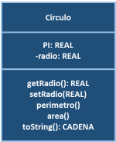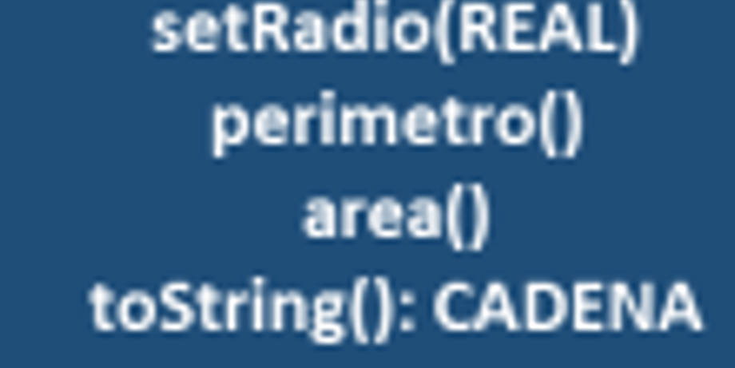

* + getPI ( ): REAL
  + getRadio ( ): REAL
  + modify ( Radius) : REAL
  + modify ( ) : Radius
* Which of the following statements is NOT an advantage of encapsulation?
  + More flexible reuse and development.
  + More reliable systems with easier maintenance.
  + Increased adaptability
  + Increases initial software construction effort